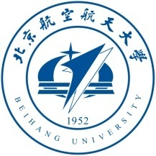
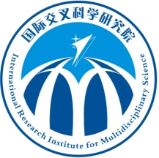
Faculty Positions Available in International Research Center for
Biological and Nature-Inspired Materials, Beihang University, China

Faculty positions are available at the International Research Institute for Multidisciplinary Science (IRIMS) at Beihang University in Beijing, specifically in the new International Research Center (IRC) for Biological & Nature-Inspired Materials, led by Professor Robert O. Ritchie. As the core part of IRIMS, this IRC is devoted to establishing a world-class, advanced and multidisciplinary research platform focused on fundamental cutting edge research in most advanced materials including biological and nature-inspired materials and biomaterials science and engineering. The Center invites applications for full-time Professors, Associate and Assistant Professors, and post-doctoral scientists, with preference given to younger candidates, e.g., recent Ph.D. graduates and post-doctoral researchers, whose research emphasis demonstrates the potential to complement and advance the IRCs existing research strengths. Successful candidates will be provided competitive salaries and start-up funds, in line with national Youth Thousand Talent Program and Beihang “Zhuoyue” Program.
Requirements & Qualifications
Youth Thousand Talent Professor: candidates should be under the age of 40; have obtained a PhD degree in a world-renowned university with at least 3 years of research experience abroad; or have obtained a PhD degree in Mainland China with at least 5 years of research and teaching experience abroad; special offers will be granted to those who have excellent research achievements during their doctoral study.
“Zhuoyue” Program Professor and Associate Professor:candidates should have a PhD degree in a world-renowned university; or have obtained a PhD degree in Mainland China with at least 2 years (Professor) or 1 year (Associate Professor) of research experience abroad; have a proven track record of faculty or research fellow positions abroad before coming to China.
We also welcome eminent scholars all over the world to join the newly-established IRC to create its international excellence.
Applicants should send curriculum vitae by email to rscrcb@buaa.edu.cn, with “IRC-Biomaterials Application” in the title. For more information, please visit the university’s Human Resource Department website http://rsc.buaa.edu.cn/, or contact us by email rscrcb@buaa.edu.cn, or by telephone 86-010-82317779.

